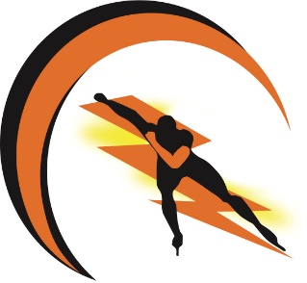
Logan City Speed
Order Form
NAME: 6
EMAIL ADDRESS: 6

Uniforms:
Price | Item |  | Size | Pocket | Quantity | Race No. (Optional) | Total Price
$115 | Skinsuit pre-order only
$130 | Skinsuit (Long Sleeve) pre-order only
$100 | Skinsuit Jacket pre-order only
$35 | Team Polo (Junior)
$0 | Team Polo (Junior) first-time members only
$35 | Team Polo (Adult)
$0 | Team Polo (Adult) first-time members only
 |  |  | Total:

Merchandise:
Price | Item | Quantity | Total Price
$40 | Merchandise Pack: Inc. LCS Drawstring Bag, Gloves, LCS water bottle, Skate Tool, Skate Laces
 |  | Total:

Training Gear:
Price | Item | Quantity | Total Price
$ | Ezeefit Ankle Booties
 |  | Total:

ORDER FORM TOTAL ($): 6
DESIGN & SIZE CHARTS
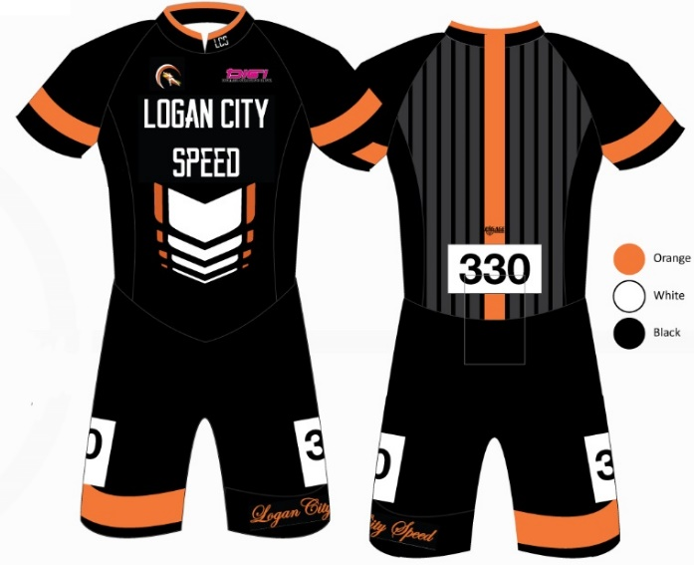

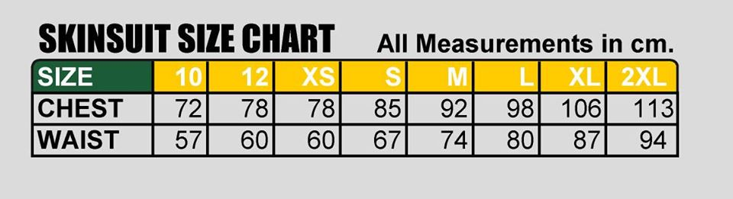

POLO SHIRT SIZING:

Junior
Available in sizes: 4, 6, 8, 10, 12, 14, 16.
Adult
Available in sizes S, M, L, XL, 2XL, 3XL

Email your order form to secretary@logancityspeed.com

